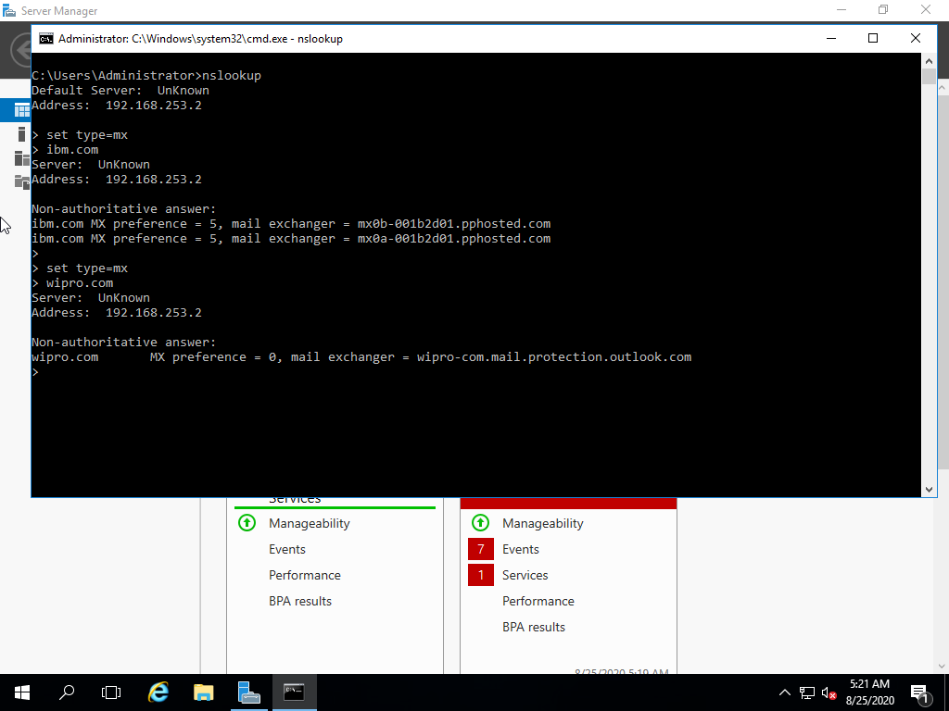**Question 1:**

Find out the mail servers of the following domain:

ibm.com

wipro.com

**Answer:**

nslookup

set type=mx

ibm.com

wipro.com

**Question 2:**

Find the locations, where these email servers are hosted.

**Answer 2:**

[**mail@ibm.com**](mailto:mail@ibm.com)

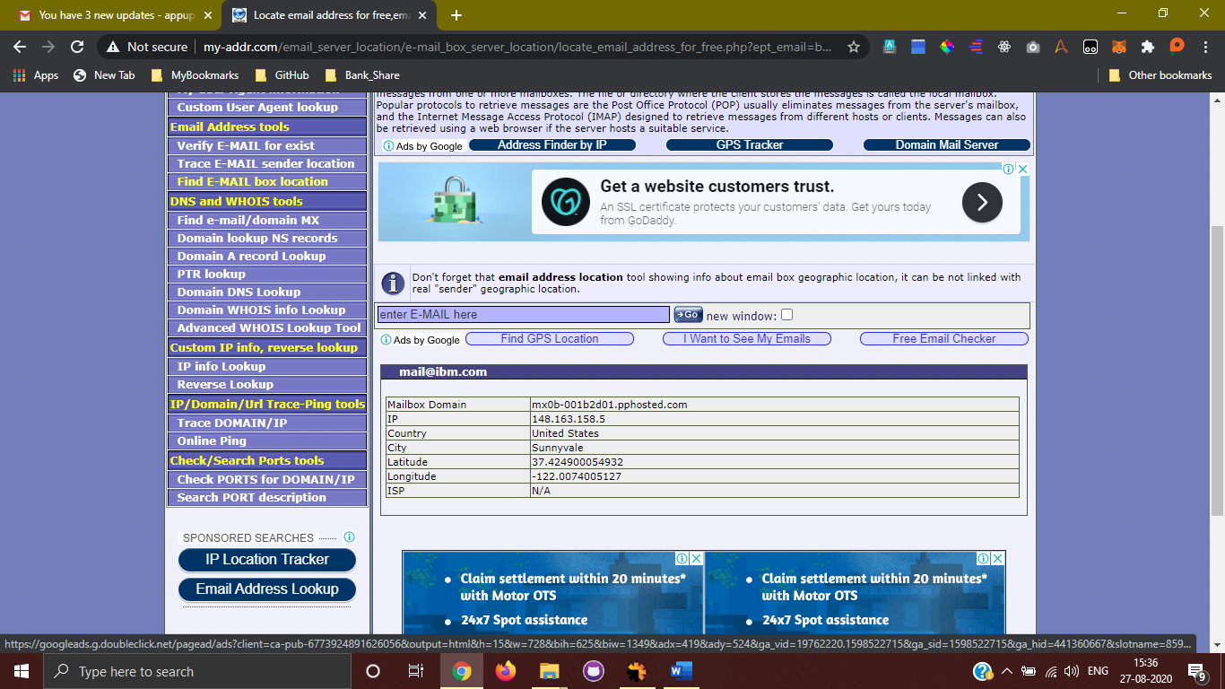

[**mail@wipro.com**](mailto:mail@wipro.com)

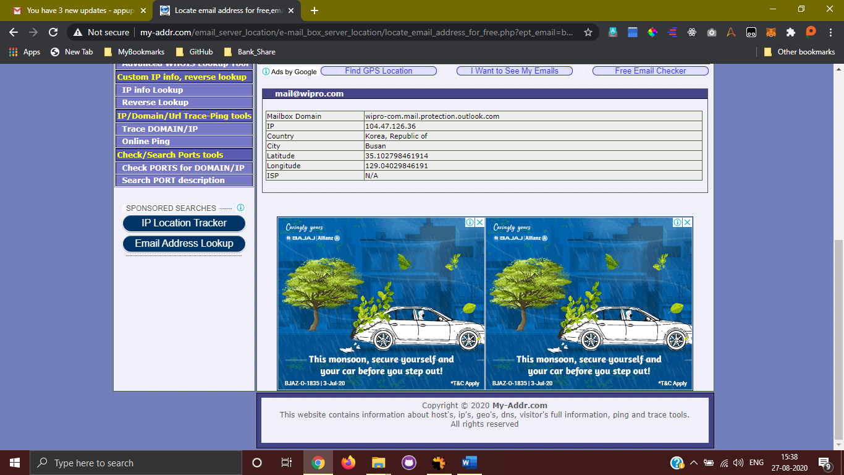

**Question 3:**

Scan and find out port numbers open 203.163.246.23

**Answer 3:**

Nmap -Pn -sS -A -v 203.163.246.23

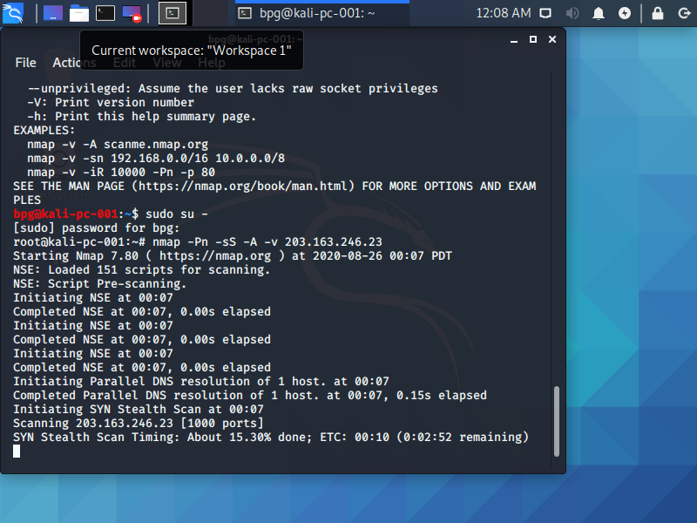 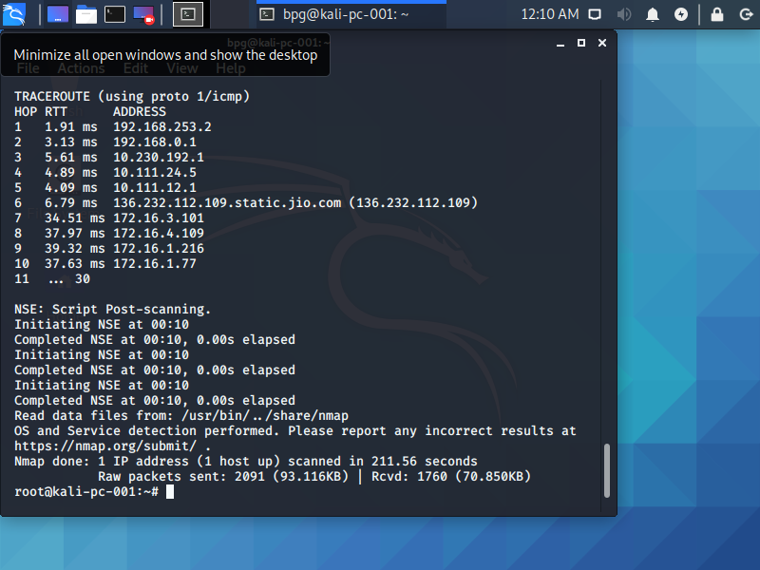

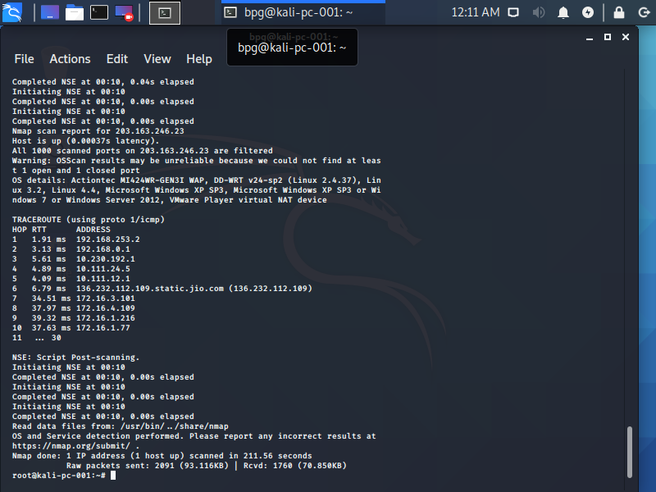

**Question 4:**

Install Nessus in VM and scan your laptop/desktop for CVE.

**Answer 4:**

File attached “**Domain_Controller-Not_29kn3k.html**”